ANNUAL DAY
AUGUST – 10TH 2012

The 49th Annual Day of Vana vani was celebrated in good style on the 10th of August, 2012 . The Chief guest was Dr. Rajeeva Karandikar, Director, Chennai Mathematical Institute. Principal Mrs. Kaveri Padmanabhan delivered the Annual Report. Head Girl Shreya Sayeelakshmi Krishnan welcomed the gathering. Dr. Rajeeva Karandikar addressed the audience and distributed the prizes to the students . Head Boy Aravind delivered the Vote of Thanks. After the formal part, a variety entertainment show was put up by the students on the theme “Rivers of India “ There were numerous dances and songs celebrating the great rivers of India. The event turned out to be a massive success and it was an evening to remember for everyone present there.
S.Aravind
HEAD BOY

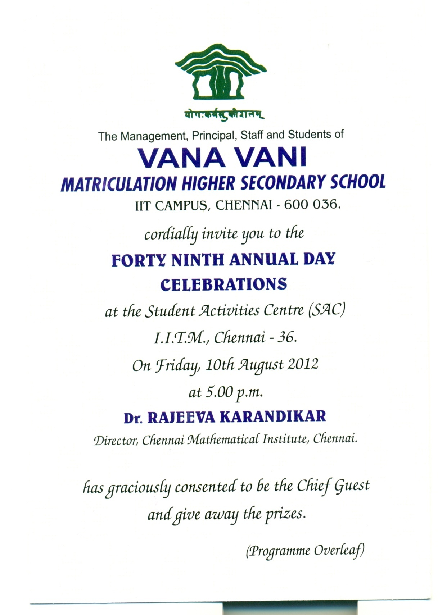

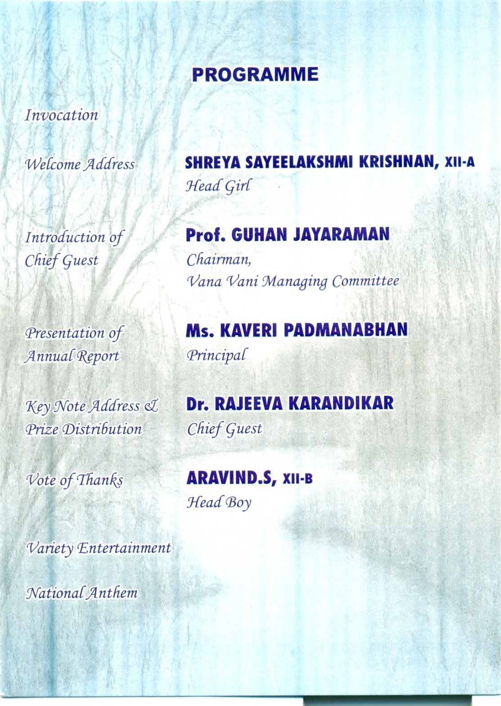

Annual day –August 10th – Photos

